Posted 10/17/2011 at 9:07 am by JAV

Municipal Building Committee

Agenda
Old Library, Fireplace Room
Thursday, Oct. 20 2011
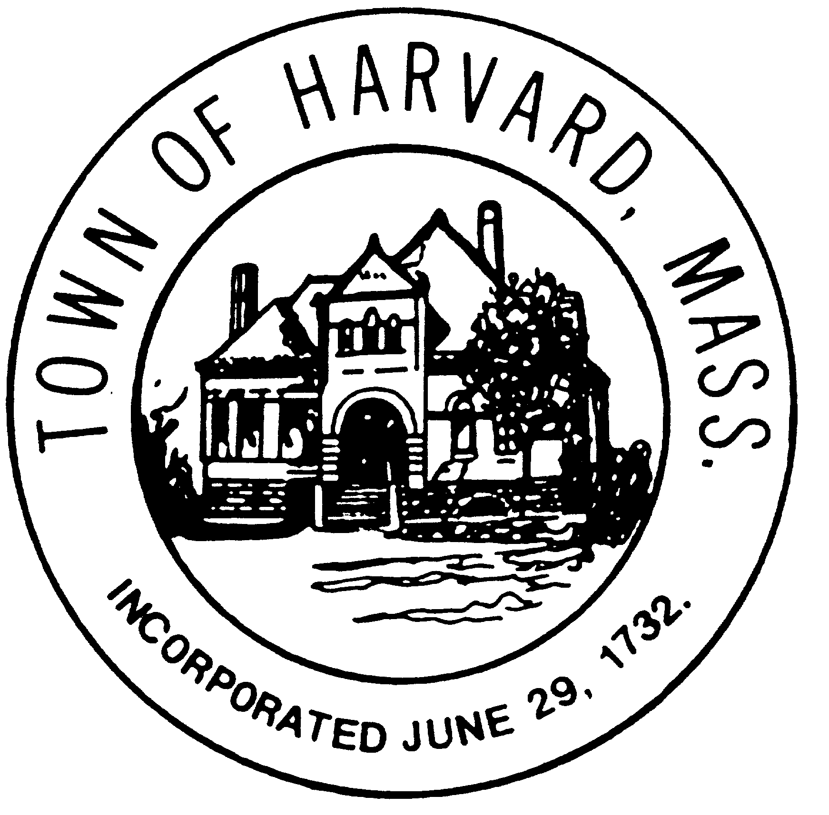
7:00 PM

- Approve minutes

- Short listing process for architects

- Agenda for next meeting

